**Test cases for (Add / edit / delete accounts ):**

|  |  |  |  |
| --- | --- | --- | --- |
| ID | Title | Steps | Expected Result |
| 1 | Verify user can press on Accounts | 1. Open app      1. Swipe from right to left to open side menu 2. Press on Accounts | 1. Application will open dashboard view 2. Side menu will appear with (Categories – Accounts- Currencies-settings ) 3. List of accounts will appear and add button and transfer button |
| 2 | Verify user can add new account successfully | 1. Open app      1. Swipe from right to left to open side menu 2. Press on Accounts 3. Press on add (+) button 4. Enter valid account name 5. Press on currency (US Dollar ) selected as default select your currency 6. Enter initial account balance 7. Select date from initial date balance 8. Select logo of new account 9. Press on add button | 1. Application will open dashboard view 2. Side menu will appear with (Categories – Accounts- Currencies-settings ) 3. List of accounts will appear and add button and transfer button 4. User will navigate to new account screen 5. Entered name will be appeared on name field 6. Popup list will be appear with all available currencies 7. Amount will appear in balance field 8. Date selected will appear in date field 9. Selected logo will be colored with green color 10. Account will be created successfully and will appear in list of accounts |
| 3 | Verify user can’t enter account name with spaces | 1. Open app      1. Swipe from right to left to open side menu 2. Press on Accounts 3. Press on add (+) button 4. Enter invalid account name like(spaces) 5. Press on add button | 1. Application will open dashboard view 2. Side menu will appear with (Categories – Accounts- Currencies-settings ) 3. List of accounts will appear and add button and transfer button 4. User will navigate to new account screen 5. Invalid data will appear on field 6. Name field will be color with red |
| 4 | Verify user can change account currency | 1. Open app      1. Swipe from right to left to open side menu 2. Press on Accounts 3. Press on any account to edit its currency 4. Press on old currency 5. Select new currency | 1. Application will open dashboard view 2. Side menu will appear with (Categories – Accounts- Currencies-settings ) 3. List of accounts will appear and add button and transfer button 4. Edit account screen will open 5. Pop-up list of currencies will appear with last selected one 6. New currency will appear in currency field |
| 5 | Verify user can switch on and off included initial balance in the balance | 1. Open app      1. Swipe from right to left to open side menu 2. Press on Accounts 3. Press on any account to edit 4. Press on switch to (off ) included on the balance then press done 5. Press on switch to (on) then press done | 1. Application will open dashboard view 2. Side menu will appear with (Categories – Accounts- Currencies-settings ) 3. List of accounts will appear and add button and transfer button 4. Edit screen will open 5. Balance shouldn’t include the initial amount of the new account . 6. Balance will include initial value plus any additional balance |
| 6 | Verify user can edit full account successfully . | 1. Open app      1. Swipe from right to left to open side menu 2. Press on Accounts 3. Press on any account to edit 4. Reenter account name 5. Change current currency 6. Reselect account logo 7. Change date of initial balance 8. Press on done button | 1. Application will open dashboard view 2. Side menu will appear with (Categories – Accounts- Currencies-settings ) 3. List of accounts will appear and add button and transfer button 4. Edit screen will open 5. New account name will be appear in field 6. New currency will be appear in the field 7. New account logo with color by green 8. Selected date will appear 9. New changes will be edited successfully . |
| 7 | Verify user can disable accounts | 1. Open app      1. Swipe from right to left to open side menu 2. Press on Accounts 3. Press on any account to edit 4. Press on three dots (more options) from header 5. Select Disable option then press done | 1. Application will open dashboard view 2. Side menu will appear with (Categories – Accounts- Currencies-settings ) 3. List of accounts will appear and add button and transfer button 4. Edit screen will open 5. List of two option will appear (Disable - Merge) 6. Account will be disabled and if user check account list account will appear with gray color and others account can’t transfer to it . |
| 8 | Verify User can enable Disabled account | 1. Open app      1. Swipe from right to left to open side menu 2. Press on Accounts 3. Press on any account to edit 4. Press on three dots (more options) from header 5. Select enable option then press done | 1. Application will open dashboard view 2. Side menu will appear with (Categories – Accounts- Currencies-settings ) 3. List of accounts will appear and add button and transfer button 4. Edit screen will open 5. List of two option will appear (Disable - Merge) 6. Account will active and user can use it and other account can transfer to it. |
| 9 | Verify user can merge between two accounts | 1. Open app      1. Swipe from right to left to open side menu 2. Press on Accounts 3. Press on any account to edit 4. Press on three dots (more options) from header 5. Press on merge 6. Select another account | 1. Application will open dashboard view 2. Side menu will appear with (Categories – Accounts- Currencies-settings ) 3. List of accounts will appear and add button and transfer button 4. Edit screen will open 5. List of two option will appear (Disable - Merge) 6. List of your accounts will be appeared to user 7. Popup message success appear to user and account will be disappeared |
| 10 | Verify merge option will not appear if there’s no another account | 1. Open app      1. Swipe from right to left to open side menu 2. Press on Accounts 3. Press on any account to edit 4. Press on three dots (more options) from header | 1. Application will open dashboard view 2. Side menu will appear with (Categories – Accounts- Currencies-settings ) 3. List of accounts will appear and add button and transfer button 4. Edit screen will open 5. List of two option will appear (Disable) |
| 11 | Verify user can delete account successfully | 1. Open app      1. Swipe from right to left to open side menu 2. Press on Accounts 3. Press on any account to edit 4. Press on delete icon 5. Press on yes button | 1. Application will open dashboard view 2. Side menu will appear with (Categories – Accounts- Currencies-settings ) 3. List of accounts will appear and add button and transfer button 4. Edit screen will open 5. Confirmation pop-up message will appear with yes and cancel button 6. Account will be deleted successfully and account will disappear from list of accounts |
| 12 | Verify user can press on cancel button on delete confirmation pop-up message | 1. Open app      1. Swipe from right to left to open side menu 2. Press on Accounts 3. Press on any account to edit 4. Press on delete icon 5. Press on cancel button | 1. Application will open dashboard view 2. Side menu will appear with (Categories – Accounts- Currencies-settings ) 3. List of accounts will appear and add button and transfer button 4. Edit screen will open 5. Confirmation pop-up message will appear with yes and cancel button 6. Confirmation pop-up will disappear and account will not deleted |
| 13 | Verify back button from add new account screen | 1. Open app      1. Swipe from right to left to open side menu 2. Press on Accounts 3. Press on add (+) button 4. Press on back button | 1. Application will open dashboard view 2. Side menu will appear with (Categories – Accounts- Currencies-settings ) 3. List of accounts will appear and add button and transfer button 4. User will navigate to new account screen 5. User will navigate to dashboard screen |
| 14 | Verify maxim limit of name of account | 1. Open app      1. Swipe from right to left to open side menu 2. Press on Accounts 3. Press on add (+) button 4. Enter more than expected length in account name 5. Press on add button | 1. Application will open dashboard view 2. Side menu will appear with (Categories – Accounts- Currencies-settings ) 3. List of accounts will appear and add button and transfer button 4. User will navigate to new account screen 5. Entered name will be appeared on name field 6. Validation message will appear |
| 15 | Verify maxim limit of balance amount | 1. Open app      1. Swipe from right to left to open side menu 2. Press on Accounts 3. Press on add (+) button 4. Enter more than expected length in account balance | 1. Application will open dashboard view 2. Side menu will appear with (Categories – Accounts- Currencies-settings ) 3. List of accounts will appear and add button and transfer button 4. User will navigate to new account screen 5. Balance will appear with limited digits |
| 16 | Verify minimum limit of name of account | 1. Open app      1. Swipe from right to left to open side menu 2. Press on Accounts 3. Press on add (+) button 4. Enter one character 5. Press on add button | 1. Application will open dashboard view 2. Side menu will appear with (Categories – Accounts- Currencies-settings ) 3. List of accounts will appear and add button and transfer button 4. User will navigate to new account screen 5. Entered name will be appeared on name field 6. Validation message will appear |

* **Test cases for Transfer feature** :

|  |  |  |  |
| --- | --- | --- | --- |
| ID | Title | Steps | Expected results |
| 1 | Verify user can navigate to transfer screen | 1. open app 2. press on transfer icon from header | 1. Application will open dashboard view. 2. User will navigate to transfer screen |
| 2 | Verify user can press on cancel button | 1. open app 2. press on transfer icon from header 3. press on cancel button | 1. Application will open dashboard view. 2. User will navigate to transfer screen 3. Transfer screen will be closed and user will navigate back . |
| 3 | Verify user can select date of transfer | 1. open app 2. press on transfer icon from header 3. press on date on the top of screen 4. select another date | 1. Application will open dashboard view. 2. User will navigate to transfer screen 3. Calendar will appear 4. Selected date will appear on the top of screen |
| 4 | Verify user can transfer successfully | 1. open app 2. press on transfer icon from header 3. enter transfer amount 4. select accounts 5. press on save button from keyboard | 1. Application will open dashboard view. 2. User will navigate to transfer screen 3. Amount will appear in amount field 4. Account A and account B will be appear 5. Transfer will be done successfully |
| 5 | Verify user can transfer from the same account to itself | 1. open app 2. press on transfer icon from header 3. enter transfer amount 4. select accounts 5. press on save button from keyboard | 1. Application will open dashboard view. 2. User will navigate to transfer screen 3. Amount will appear in amount field 4. Account A and account A will be appear 5. Validation message will appear |
| 6 | Verify User can writ note | 1. open app 2. press on transfer icon from header 3. enter transfer amount 4. select accounts 5. write note 6. press on save button from keyboard | 1. Application will open dashboard view. 2. User will navigate to transfer screen 3. Amount will appear in amount field 4. Account A and account B will be appear 5. Note will appear on note field 6. Transfer will be done successfully |
| 7 | Verify maximum limit of note | 1. open app 2. press on transfer icon from header 3. enter transfer amount 4. select accounts 5. write note with maximum limit | 1. Application will open dashboard view. 2. User will navigate to transfer screen 3. Amount will appear in amount field 4. Account A and account B will be appear 5. Validation message will be appear |
| 8 | Verify user can’t enter spaces on note | 1. open app 2. press on transfer icon from header 3. enter transfer amount 4. select accounts 5. write note with spaces | 1. Application will open dashboard view. 2. User will navigate to transfer screen 3. Amount will appear in amount field 4. Account A and account B will be appear 5. Validation message will be appear |
| 9 | Verify user can’t transfer with zero | 1. open app 2. press on transfer icon from header 3. enter transfer amount with zero | 1. Application will open dashboard view. 2. User will navigate to transfer screen 3. Validation message will appear |
| 10 | Verify maximum limit of amount of transfer | 1. open app 2. press on transfer icon from header 3. enter transfer amount maximum limit | 1. Application will open dashboard view. 2. User will navigate to transfer screen 3. Amount field will take maximum digits only |
| 11 | Verify user can edit amount after transfer | 1. Open app 2. Press on balance from dashboard to view details 3. Select transfer transaction 4. Edit with transfer amount 5. Press on done button | 1. Application will open dashboard view. 2. Balance screen details will appear 3. Transfer screen will appear 4. New amount will appear on field 5. Transfer transaction will be updated |
| 12 | Verify user can edit note after transfer | 1. Open app 2. Press on balance from dashboard to view details 3. Select transfer transaction 4. Edit note 5. Press on done button | 1. Application will open dashboard view. 2. Balance screen details will appear 3. Transfer screen will appear 4. New note will be appear 5. Transfer transaction will be updated |
| 13 | Verify user can change sender and recipient accounts | 1. Open app 2. Press on balance from dashboard to view details 3. Select transfer transaction 4. select accounts 5. press on done | 1. Application will open dashboard view. 2. Balance screen details will appear 3. Transfer screen will appear 4. Account A and account A will be appear      1. Validation message will appear |
| 14 | Verify user can delete transfer | 1. Open app 2. Press on balance from dashboard to view details 3. Select transfer transaction 4. Press on delete icons | 1. Application will open dashboard view. 2. Balance screen details will appear 3. Transfer screen will appear 4. Transaction will delete successfully |

Kindly check below bullet points for categories :

* User can add expense . priority 1 from business
* User can delete expenses.
* User can edit expenses .
* User can enter income. . priority 1 from business

Kindly check below bullet points for settings :

* User can handle budget mode . . priority 1 from business
* User can select dark mode .
* User can change language . . priority 1 from business
* User can change currency and enter exchange rate . . priority 1 from business
* User can handle start date of week .
* User can handle start date of month .
* User can export his data
* User can restore his data . priority 1 from business
* User can create backup of his data . priority 1 from business
* User can reset all app changes. .

Kindly check below bullet points for filter by date :

* User can filter with (day/ week / month/ year/ all / select specific date from calendar )

Kindly check below bullet points for dashboard:

* User can add expenses . priority 1 from business
* User can edit expenses . . priority 1 from business
* User can delete expenses. . priority 1 from business
* User can add balance . priority 1 from business
* User can edit balance . . priority 1 from business
* User can track charts which represent balance and expenses and updated balance . priority 1 from business
* User can change date of dashboard

**Defects:**

1. Title : Although account is disabled view of that account appears to user and user can make any change on it.

Reproducible Steps:

1. **Open app**
2. **Press on more options from header in dashboard screen**
3. **Press on accounts**
4. **Press on add to create new account**
5. **Fill all data in adding form**
6. **Press save**
7. **From dashboard screen make any transaction (like add balance or add expenses )**
8. **Open side menu again**
9. **Select accounts**
10. **Select the new account**
11. **Edit it to disable**
12. **Check dashboard screen**

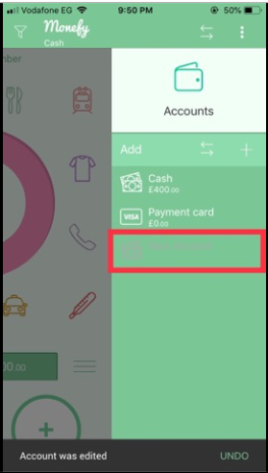 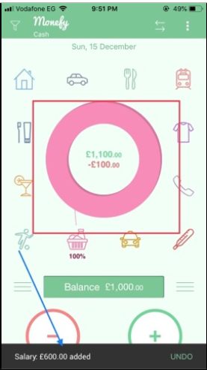

Affected devices : iphone XR

Netwrok : Vodafone

Severity : High

Priority : 2

Impact : that’s make any account disable can be used like active one .

1. Title: when enable account and select it from list of account all old transaction will be cleared unless initial balance amount.

Reproducible Steps:

1. **Open app**
2. **Press on more options from header in dashboard screen**
3. **Press on accounts**
4. **Press on add to create new account**
5. **Fill all data in adding form**
6. **Press save**
7. **From dashboard screen make any transaction (like add balance or add expenses )**
8. **Open side menu again**
9. **Select accounts**
10. **Select the new account**
11. **Edit it to disable**
12. **Make account enable again**
13. **Check dashboard screen**

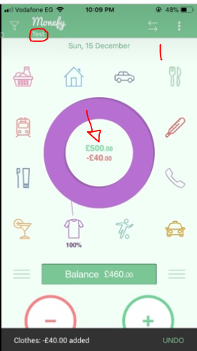 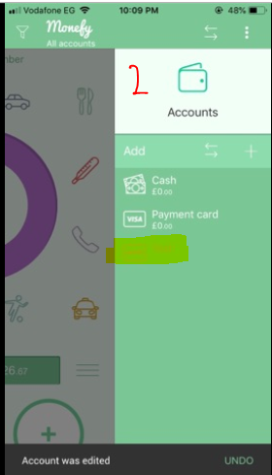 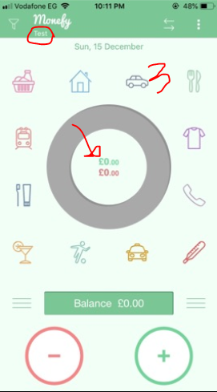

Affected devices : iphone XR

Netwrok : Vodafone

Severity : High

Priority : 1

Impact : all data saved with disabled account will be cleared .

1. Title : validation messages overlapping each other when user try to merg to accounts .

Reproducible Steps:

1. **Open app**
2. **Press on more options from header in dashboard screen**
3. **Press on accounts**
4. **Select cash account**
5. **Press on more options**
6. **Select merge**
7. **Check validation**

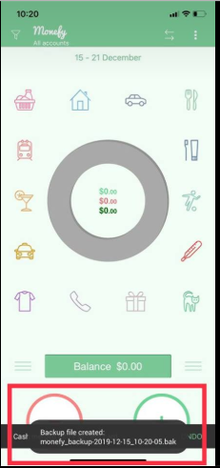

Affected devices : iphone XR

Netwrok : Vodafone

Severity : medium

Priority : 1

Impact : user can’t read all validations .

1. Title : use can write note and balance in the same time as keyboard of number can open with keyboard of characher

Reproducible Steps:

1. **Open app**
2. **Press on balance from dashbaord screen**
3. **Write note from character keyboard**
4. **Enter numbers from numbers keyboard**

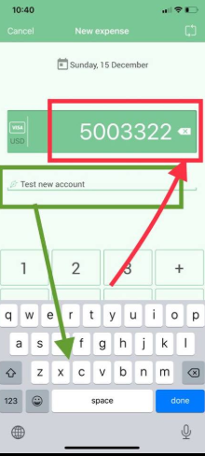

Affected devices : iphone XR

Netwrok : Vodafone

Severity : medium

Priority : 2

Impact : user shouldn’t view two keyboard in the same time .

1. There’s back button to close keyboard in transfer screen

Reproducible Steps:

1. **Open app**
2. **Press on transfer icon**
3. **Enter amount**
4. **Check back button behavior**

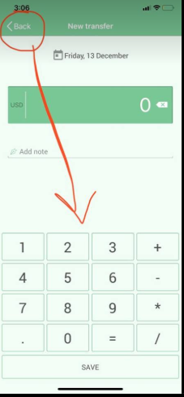

Affected devices : iphone XR

Netwrok : Vodafone

Severity : medium

Priority : 1

Impact : button behavior is wrong in back button user expect to navigate back not

close the keyboard .

1. There’s no empty state for accounts .

Reproducible Steps:

1. **Open app**
2. **Press on more options from header in dashboard screen**
3. **Press on accounts**
4. **Delete all accounts**
5. **Check accounts again**

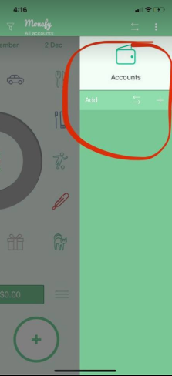

Affected devices : iphone XR

Netwrok : Vodafone

Severity : medium

Priority : 2

Impact : account list should include empty state to tell user to start adding new

accounts .

1. There’s an expenses not include indicator to charts like others

Reproducible Steps:

1. **Open app**
2. **Start adding more expenses for all categories with random amount**
3. **Check last one**

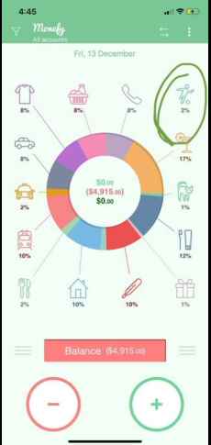

Affected devices : iphone XR

Netwrok : Vodafone

Severity : Low

Priority : 3

**UX comments :**

1. List of currencies / languanges should include close icon .

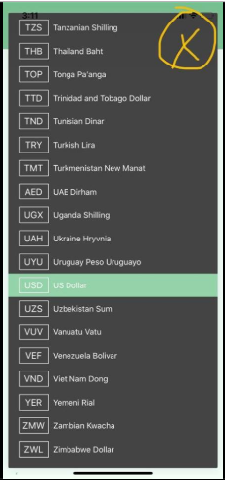

1. Note area in transfer or in any screen is small and need to be with bigger size specially if user enter long comment .
2. Filter expenses with spicifc category it will be useful